
Software Engineering Department
Capstone Project Phase A

MsgGuard - Generative AI for Phishing Detection and Prevention

Github: https://github.com/Eleia522000/phishing-ai-detector

Supervisor: Dr. Reuven Cohen

Submitted by:

Name Eleia Elias Enab Fouad
ID 208173021 212697239
E-mail Eleia.elias@e.braude.ac.il Enab.fouad@e.braude.ac.il

Table of Contents
Contents
Abstract 3
1. Introduction 4
1.1 The Problem We Want to Solve 4
1.2 Existing Solutions Today 4
1.3 Our Solution 4
1.4 Stakeholders 6
1.5 Document Structure 6
2. Literature Review 6
2.1 Existing Tools and Methods for Phishing Detection 6
2.2 Existing Tools 7
2.3 The Need for This Project 9
3. Expected Achievements 10
3.1 Primary Objectives 10
3.2 Expected System Performance 10
3.3 Success Criteria 10
4. Engineering Process 11
4.1 Process 11
4.1.1 Motivation 11
4.1.2 Research and Problem Analysis 11
4.1.3 System Requirements 12
4.1.4 General Description of the System 13
4.1.5 Technologies 14
4.1.6 Dataset Description and Usage 14
4.1.7 Development Plan 15
4.1.8 Challenges And Constraints 15
4.2 Product 17
4.2.1 Software Architecture 17
4.2.2 Use Case Diagram 19
4.2.3 Activity Diagram 20
4.2.4 User Interface (UI) 21
5. Verification And Evaluation 23
5.1 Verification 23
5.2 Evaluation 24
6. References 26

Abstract
Phishing remains one of the most damaging cyber-threats, with attackers constantly creating new domains that imitate trusted brands. While modern ML and deep-learning models perform well on known datasets, research shows they still struggle with newly created domains, unfamiliar URL structures, and realistic brand-imitation attacks that were not part of their training.
To address these gaps, this project proposes a lightweight phishing-detection system for domains, that enhances URL analysis using three identity-based verification signals.
The system uses a compact multi-stage pipeline. First, it examines the raw URL, and analyse the character-level and structural patterns typical of phishing, such as deceptive subdomains, unusual character sequences, or subtle misspellings. Next, the system extracts identity-level features: domain age , hosting-origin region (IP-geolocation), and brand-domain consistency
In the final stage, the system combines structural analyses with the identity-based signals to classify the URL as legitimate, suspicious, or phishing. This hybrid approach strengthens detection of sophisticated impersonation attempts and zero-day phishing URLs, showing that identity-oriented verification can meaningfully improve modern ML-based detection. The result is a practical, modular, and extensible framework suitable for real-world phishing-protection environments.

1. Introduction

1.1 The Problem We Want to Solve
Phishing attacks have become increasingly difficult to detect as attackers adopt strategies that closely mimic legitimate brands. By generating look-alike domains, modifying URL structures, or using hosting services that obscure their true origin, attackers create links that appear trustworthy to users and automated filters alike. Despite advancements in machine learning and deep learning, research shows that many detection systems struggle with newly created phishing URLs, unfamiliar domain patterns, and realistic imitating legitimate brands. As a result, users are frequently exposed to malicious links that appear legitimate and are difficult to distinguish from authentic communication.

1.2 Existing Solutions Today
Phishing-detection systems are generally divided into rule-based, machine-learning, and deep-learning approaches. Rule-based methods rely on blacklists and simple URL heuristics, but they cannot detect new or slightly modified phishing sites. Classical ML models such as Logistic Regression, Random Forest, and SVM learn relationships between engineered URL features and phishing likelihood, improving accuracy but still struggling with highly deceptive or visually similar phishing pages [1][2][4][5].
Deep-learning approaches achieve stronger results by learning patterns directly from raw data. CNN models (including 1D-CNN) capture character-level and structural irregularities in URLs and webpage content [8][9]. LSTM and RNN models analyse sequential information in emails and messages, improving detection of text-based phishing attempts [3][4]. Hybrid CNN–LSTM systems typically reach 95%–99% accuracy across datasets such as PhishTank, UCI, and PhiUSIIL, while stacked LSTMs provide improved generalization to newly crafted URLs [3][4][7]. Simpler models like FCNNs also perform well when trained on modern datasets [9].
Unsupervised anomaly-detection models, especially Isolation Forest, identify unusual or rare URL patterns and are often used as a preprocessing step to boost classifier performance on challenging datasets [10].

1.3 Our Solution
We propose a phishing-detection system that incorporates several verification steps designed to address limitations highlighted in recent research. Current ML/DL models often struggle with newly registered domains, unfamiliar URL structures, and deceptive URLs that closely resemble legitimate websites, because these attacks do not appear in their training datasets and therefore bypass traditional pattern-based detection. To strengthen early detection, the system also examines basic characteristics of the message itself—such as the sender address and the wording of the message—and will use a transformer-based model such as BERT which analyzes the meaning and context of words rather than just their order, making it highly effective for identifying text-based patterns commonly seen in phishing messages. After this initial inspection, the system applies three core identity-based verification components that form the foundation of the proposed solution.
- Domain Age Verification
Attackers often register new domains specifically for phishing. By checking the domain’s creation date, the system identifies suspicious links that appear legitimate but have only existed for a short time. This check uses a WHOIS lookup module combined with lightweight URL preprocessing before feeding the URL into our deep-learning components. The age result becomes one of the inputs to the final classifier.
- Hosting-Origin Consistency Analysis
Legitimate brands typically host their websites in stable, well-defined geographic or organizational regions. By comparing the hosting region of a suspicious URL to the expected region of the claimed brand, the system detects inconsistencies often used in phishing attacks. This module uses IP-to-location lookup APIs to extract the hosting-origin information, and the resulting features are then combined with the 1D-CNN-based URL analyzer, which focuses on learning character-level URL patterns. The CNN model is used here to evaluate the structure of the URL itself—catching misspellings, misleading subdomains, or unusual domain constructions—while the hosting-origin data provides an identity-based signal; Using these methods together, the system detects phishing attempts that appear geographically legitimate but still contain suspicious URL characteristics.
- Brand-Domain Consistency Check
This component ensures that the main domain of the link matches the official domain of the brand (e.g., paypal.com, amazon.com). The system flags deceptive variations—such as misspellings, unusual top-level domains (TLDs), or misleading subdomain structures—that commonly appear in phishing scams. To analyze these patterns more effectively, we apply a 1D-CNN model that processes the URL as a sequence of characters and learns local structural patterns. This enables it to detect small but meaningful deviations in spelling, symbol placement, and domain structure that often indicate phishing attempts.
These identity-based components strengthen existing phishing-detection systems by adding verification signals that do not depend on training data and therefore cannot be bypassed by newly created or unfamiliar URL patterns. Traditional models focus on structural or text-based patterns learned from previous datasets, but our identity checks validate domain characteristics—such as creation date, hosting region, and alignment with the brand’s real domain. This combination provides a more reliable defense, especially against zero-day phishing links, which are newly created malicious URLS that have never appeared in blacklists or training sets and often bypass standard detection methods.

1.4 Stakeholders
The proposed system provides value to several key stakeholders. Users gain stronger protection against realistic brand-impersonation attacks that closely imitate legitimate organizations, reducing the risk of falling victim to fraudulent links. Companies and brands benefit by having fewer impersonation attempts, lowering the chances of fraud, reputational damage, and unauthorized access arising from phishing-based attacks. Cybersecurity teams receive an additional verification layer that enhances existing phishing filters and supports more accurate incident-response decisions. Finally, email providers and browsers can integrate the identity-checking layer to reinforce their detection mechanisms and reduce false negatives in phishing-warning systems, ultimately improving overall security for their platforms.

1.5 Document Structure
- Chapter 1 – Introduction: Defines the problem, summarizes existing solutions, outlines project goals, and identifies stakeholders.
- Chapter 2 – Literature Review: Presents the research foundations of phishing detection, covering ML/DL approaches, practical systems, and persistent limitations documented across academic studies.
- Chapter 3 – Proposed Solution: Describes the system architecture and explains the three identity-verification components: domain age, hosting region, and brand-domain matching.
- Chapter 4 – Methodology: Details the tools, APIs, datasets, evaluation process, and integration methods used to implement and test the system.
- Chapter 5 – Expected Results: Summarizes anticipated contributions, such as improved detection of brand-impersonation attacks and enhanced robustness against zero-day phishing links.
- Chapter 6 – Conclusion: Provides an overall summary and suggests directions for future enhancements, such as combining identity signals with deep-learning URL models or browser integration.

2. Literature Review

2.1 Existing Tools and Methods for Phishing Detection
Existing phishing-detection tools can be grouped into rule-based systems, classical machine-learning models, and advanced deep-learning approaches. Traditional methods rely on blacklist checks—databases of known malicious URLs or domains—and simply block a link if it already appears on the list. However, blacklists cannot detect new phishing websites that were never seen before. Other rule-based techniques analyze URL characteristics such as unusual length, suspicious character patterns, or odd domain structures, but attackers easily bypass these rules by slightly modifying the URL. Machine-learning models like Logistic Regression, which calculates how strongly each URL feature contributes to the probability that the link is phishing [2], Random Forest, which combines many decision trees to catch complex patterns [5], and Support Vector Machines (SVMs), which find the optimal boundary separating phishing from legitimate links [2], improve accuracy by learning from data rather than relying only on rules. Still, these classical ML models depend on manually engineered URL features and often struggle with sophisticated or highly deceptive phishing pages [1][4].
Deep learning provides stronger performance:
• Convolutional Neural Networks (CNN), including 1D-CNN variants, detect character-level and structural patterns in URLs or webpage content [8][9].
• Long Short-Term Memory (LSTM) networks and Recurrent Neural Networks (RNNs) analyze sequential patterns in email text or message wording [3][4].
• Hybrid CNN–LSTM architectures, which combine structure detection and sequence understanding, consistently achieve 95%–99% accuracy across datasets such as PhishTank, UCI, and PhiUSIIL [3][4][7].
• Stacked LSTM architectures (multiple LSTM layers) learn deeper and more complex sequential patterns, enabling stronger generalization to newly crafted or obfuscated URLs [7].
• Fully Connected Neural Networks (FCNNs) learn statistical relationships in numerical URL features and show strong performance on modern datasets such as PhiUSIIL, especially when combined with feature engineering [9].
• Autoencoders learn the normal structure of legitimate URLs or webpage features and flag phishing samples through high reconstruction error, making them effective for suspicious-pattern detection [6][4].
• Anomaly-Detection Approaches (e.g., Isolation Forest)
These models focus on identifying unusual or abnormal patterns instead of performing direct classification. Isolation Forest detects outlier URLs by isolating data points through recursive feature splits, helping identify suspicious or rare URL behaviors. It is often used as a preprocessing step to enhance the performance of classifiers by filtering out noisy samples[10].

2.2 Existing Tools
A variety of phishing-detection systems have been implemented in recent years, demonstrating different approaches and levels of sophistication. The following studies illustrate how machine-learning and deep-learning techniques are applied in real-world phishing detection scenarios.
• Hybrid CNN–LSTM Email Phishing Detector — (Kim & Lee, 2023)[3]
A hybrid deep-learning system combining CNN layers (for text patterns) and LSTM layers (for sequential context).
Achieved 97% accuracy on ~10,000 phishing + legitimate emails.
• Low-Latency Random-Forest URL Filtering System — (Rodriguez et al., 2024)[5]
A real-time Random-Forest-based URL detector optimized for millisecond-level inference.
Suitable for enterprise email gateways and high-traffic servers.
• AntiPhishStack: Stacked LSTM for URL Classification — (Huang & Patel, 2024)[7]
A multi-layer LSTM architecture trained on lexical + statistical URL features.
Reached up to 99% accuracy and performs well on newly generated phishing URLs.
• 1D-CNN Phishing URL Analyzer — (Singh & Al-Harbi, 2024)[8]
Applies a 1D CNN directly to raw URL strings, capturing character-level structures.
Reported 99.7% accuracy, among the strongest URL-only models.
• Fully Connected Neural Network on PhiUSIIL Dataset — (Ahmed et al., 2025)[9]
A deep FCNN leveraging the updated PhiUSIIL dataset.
Shows that simple architectures can remain highly effective with modern datasets.
• EXPLICATE: Explainable AI Phishing Classifier — (Carter & Zhou, 2025)[6]
An explainability-focused system using SHAP, LIME, and LLM-based summaries.
Maintains ~96% accuracy while improving transparency.
• Deep-Learning Taxonomy for Phishing Detection (CNN/LSTM/RNN/AE) — (Singh & Morgan, 2022–2023)[1]
A broad analytical survey evaluating CNN, LSTM, RNN, and Autoencoder models across multiple datasets.
Typical performance ranges 95–98% accuracy.
• Multi-Input Deep-Learning System (URL + HTML + Text + Screenshot) — (Das & Fernandes, 2022)[4]
A multimodal phishing-detection architecture analyzing URLs, HTML structure, text, and visual webpage data.
Provides robust detection across diverse attack vectors.
• Isolation-Forest + Random-Forest Hybrid Detection Pipeline — (Omar & Shrestha, 2025)[10]
Combines anomaly detection (Isolation Forest) with supervised ML (Random Forest).
Achieved 96.78% accuracy, 97.20% recall, 96.64% F1-score on 11,430 URLs.

2.3 The Need for This Project
Although many tools exist, current research consistently emphasizes several challenges:
1. Phishing attacks evolve rapidly
- Attackers continuously generate new phishing URLs.
- Domain structures and hosting configurations are frequently modified.
- Email wording and webpage content are updated to bypass detection filters.
- Therefore, static blacklists and fixed rule-based systems are insufficient against modern threats.
2. Deep-learning models struggle with unseen or zero-day phishing
- CNN, LSTM, hybrid CNN–LSTM, and stacked LSTM models achieve high accuracy on benchmark datasets.
- Performance significantly declines on newly registered domains and unfamiliar URL patterns.
- Models often fail to generalize to new phishing strategies.
- Generalization remains a critical limitation. [7]
3. Dependence on datasets limits robustness
- Many ML/DL models rely on curated datasets such as PhishTank, UCI, and PhiUSIIL.
- These datasets do not fully represent emerging phishing techniques.
- New phishing variants may not match the training data distribution.
- This leads to reduced detection of novel attacks.
4. Phishing leverages psychological manipulation
- Attackers exploit urgency, fear, and authority to influence users.
- Visual similarity to trusted brands increases user trust in fraudulent messages.
- Human factors remain a major vulnerability in phishing attacks.
- Technical filters alone cannot fully mitigate user susceptibility.

5. Explainability and transparency remain weak
- Users and security teams often struggle to trust AI-based classifiers.
- Many detection systems provide limited insight into classification decisions.
- Explainability methods such as SHAP and LIME have been proposed.
– LIME (Local Interpretable Model-agnostic Explanations) explains individual predictions by approximating the model locally and identifying the most influential features for a specific decision.
– SHAP (SHapley Additive exPlanations) assigns each feature a contribution score based on game theory, showing how features influence the final prediction.
- However, explainability is still not widely integrated into operational systems.

3. Expected Achievements

3.1 Primary Objectives
The primary objective of this project is to develop a lightweight and explainable phishing detection system that analyzes suspicious URLs using identity-based indicators. The system is expected to automatically evaluate domain age, hosting-origin consistency, and brand–domain similarity in order to detect phishing attempts and brand impersonation. Through the analysis of representative legitimate and phishing URLs, the project aims to demonstrate how each evaluation component contributes to the final classification decision in a transparent and understandable manner.

3.2 Expected System Performance
The system is expected to analyze submitted URLs efficiently and provide a phishing classification within 3–5 seconds per URL. It should reliably identify newly registered domains, detect inconsistencies between hosting origin and legitimate brand behavior, and recognize deceptive domain structures commonly used in phishing attacks. The system is also expected to produce consistent and explainable results, where the contribution of each evaluation component to the final decision can be clearly understood.

3.3 Success Criteria
The project will be considered successful if the system meets the following measurable criteria when evaluated using standard datasets of legitimate and phishing URLs such as PhishTank and OpenPhish.
• Correct identification of known phishing URLs
The system correctly identifies between 90% and 95% of known phishing URLs when evaluated on benchmark datasets containing previously reported phishing domains.
These datasets include well-documented phishing links that impersonate services such as PayPal, Amazon, Microsoft, and banking platforms. Success under this criterion means that the system consistently flags URLs that are already recognized as malicious, demonstrating that the core detection pipeline functions reliably and does not miss obvious phishing threats.
• Identity checks improve detection accuracy
The inclusion of identity-based features—such as domain age analysis, hosting-origin consistency, and brand–domain matching—is expected to improve overall detection accuracy by 5% to 10% compared to a baseline machine-learning model that relies only on standard URL-pattern or content-based features. For example, if the baseline model achieves an accuracy of approximately 80%, the enhanced system is expected to reach 85%–90% accuracy when identity verification is added.
This improvement is measured by comparing classification results on the same evaluation datasets, particularly in borderline or ambiguous cases where traditional models may misclassify phishing URLs as legitimate. Achieving this criterion demonstrates the added value and practical impact of the proposed identity-oriented approach.
• Clear explanation for each alert
The system is expected to provide an understandable explanation for every phishing classification, where each alert includes at least one concrete and interpretable reason supporting the decision. These reasons may include indicators such as newly registered domains, brand–domain mismatches, suspicious hosting locations, or abnormal URL structures. Providing explicit explanations enables users and security analysts to better understand why a URL was classified as phishing and increases trust in the system’s decisions. This criterion ensures that the system does not function as a black-box classifier, but instead offers transparent and justifiable outputs that support effective incident response and user awareness.

4. Engineering Process

4.1 Process
This section describes the engineering development process of the proposed system, including completed design stages and planned implementation phases. It explains the reasoning behind the selected methodology and workflow, as well as the key constraints that influence the development approach.

4.1.1 Motivation
Newly created and zero-day phishing websites remain difficult to detect despite high reported accuracy in existing systems. This motivates an identity-based approach that emphasizes domain age, hosting origin, and brand-domain consistency.

4.1.2 Research and Problem Analysis
The research and problem analysis phase focused on examining existing phishing-detection technologies and identifying their limitations. This stage included:
- studying URL-based, email-based, and webpage-based detection models
- examining techniques such as Convolutional Neural Networks (CNN), Long Short-Term Memory networks (LSTM), hybrid CNN–LSTM models, stacked LSTM architectures, Fully Connected Neural Networks (FCNN), and real-time Random Forest systems
- understanding the challenges these approaches face when dealing with previously unseen or zero-day phishing attacks
- identifying that many existing phishing-detection systems give limited consideration to domain-level identity features, including domain age, hosting location, and brand-domain matching
This analysis provided the rationale for developing a lightweight phishing-detection system that uses domain-level indicators such as registration age, hosting region, and brand-domain consistency.

4.1.3 System Requirements
Functional Requirements
- The system allows the user to submit a URL for analysis.
- The system allows validating that the submitted input is a correctly formatted URL.
- The system allows extracting the main domain, subdomains, and top-level domain from the URL.
- The system allows analyzing the domain registration age using domain-information services.
- The system allows identifying recently registered domains as potentially suspicious.
- The system allows resolving the IP address associated with the submitted URL.
- The system allows retrieving hosting location or organizational information for the URL.
- The system allows comparing the hosting origin with expected hosting regions of known brands.
- The system allows comparing the suspicious domain with official brand domains.
- The system allows detecting misspellings, incorrect TLDs, and misleading domain structures.
- The system allows combining domain-age, hosting-origin, and brand-domain analyses using rule-based logic.
- The system allows classifying the URL as Legitimate, Suspicious, or Likely Phishing.
- The system allows presenting the final classification result to the user.
- The system allows displaying explanatory indicators that contributed to the classification decision.

Non-Functional Requirements
- The system should provide analysis results in near real time, with a response time of 3–5 seconds per URL, excluding delays caused by external API services.
- The system should operate reliably and produce consistent results for repeated analyses of the same URL.
- The system should be easy to use, requiring only a single URL input from the user.
- The system should present results in a clear and understandable manner for non-expert users.
- The system should be modular, allowing individual components to be maintained or updated independently.
- The system must not load or execute any potentially malicious website content during analysis.
- The system should support future extensions, such as adding new domain-based analysis modules.

4.1.4 General Description of the System
- The system is designed as a modular pipeline composed of multiple analysis components that operate sequentially on a suspicious URL or message. In the first stage, a baseline machine-learning or deep-learning model, such as a BERT-based text or URL analyzer, is used to extract initial structural or semantic signals. These signals are then complemented by identity-based components that evaluate domain-level characteristics. This modular structure allows each component to operate independently while contributing to the final classification decision.
- Domain Age Verification Module – evaluates how long the domain has been registered, as recently created domains are commonly associated with phishing attacks.
- Hosting-Origin Consistency Module – examines the geographic or organizational location of the hosting server and compares it with expected hosting patterns of known brands.
- Brand–Domain Matching Module – analyzes whether the domain structure matches the official domain of the brand it claims to represent, detecting misspellings, incorrect top-level domains, or misleading subdomains.
The outputs of these modules are combined by a simple decision-logic layer, which determines whether the URL should be classified as legitimate, suspicious, or likely phishing.

4.1.5 Technologies
- Programming Language – Python
The system is implemented in Python due to its simplicity, readability, and strong support for networking, security-related tasks, and integration with external services.
- Domain Registration Analysis – WHOIS API
Domain registration data is retrieved using a WHOIS API to calculate domain age, which is a key indicator for identifying newly created phishing domains.
- Hosting-Origin Analysis – IP Resolution and Geolocation Service
The system resolves the IP address associated with a submitted URL and queries an IP-geolocation service to obtain geographic or organizational hosting information, enabling hosting-origin consistency checks.
- URL Parsing and Structural Analysis – Python Standard Libraries
Standard Python libraries are used to extract the main domain, subdomains, and top-level domain from URLs, allowing detection of misspellings, misleading subdomains, and irregular TLD usage.
- Decision Logic and Explainability – Rule-Based Classification
The outputs of all identity-based checks are combined using simple rule-based decision logic, ensuring transparency and explainability in the final classification of URLs as legitimate, suspicious, or likely phishing.

4.1.6 Dataset Description and Usage
This project uses the Majestic Million dataset as a source of legitimate domains for training and evaluation. The Majestic Million is a publicly available dataset containing the top one million most popular and reputable domains on the Internet, ranked based on backlink and web visibility data.
The dataset represents well-established and trusted websites and is therefore used as the legitimate (benign) class in the phishing detection process. It provides a reliable baseline for learning normal domain structures, common URL patterns, and stable domain characteristics.
During the training phase, domains from the Majestic Million dataset are explicitly labeled as legitimate and merged into a single labeled training dataset together with phishing samples from sources such as PhishTank or OpenPhish, enabling supervised learning.
During the prediction phase, suspicious URLs are evaluated against the learned patterns of legitimate domains. URLs that significantly deviate from this baseline—such as newly registered domains or misleading domain structures—are more likely to be classified as phishing.
Using the Majestic Million dataset helps reduce false positives and improves the system’s ability to distinguish between legitimate websites and phishing attempts.

4.1.7 Development Plan
The upcoming engineering tasks steps will be as follows:
- Domain Age Retrieval Using a WHOIS API
A WHOIS API will be used to retrieve the initial registration date of a domain.
- URL Decomposition and Brand–Domain Comparison
The system will implement logic to decompose each URL into its main domain, subdomains, and top-level domain.
- IP Resolution and Hosting-Origin Analysis
The URL’s domain will be resolved to its corresponding IP address, which will then be queried using an IP-geolocation service.
- Creation of a Test URL Dataset
A dataset containing both legitimate and phishing URLs will be created to support system testing. This dataset will include clear phishing examples as well as benign URLs to ensure balanced evaluation.
- System Validation and Testing
The system will be validated using the prepared dataset. Performance will be assessed by comparing the system’s predictions against known phishing and legitimate cases.

4.1.8 Challenges And Constraints
Several constraints influence the development:
• Evasion by Advanced Phishing Attacks
Some phishing campaigns use older or previously compromised domains and well-known hosting providers, reducing the effectiveness of indicators such as domain age and hosting origin.
Mitigation: To address this challenge, the system does not rely on a single identity indicator, but combines multiple signals such as brand–domain consistency, URL structure analysis, and machine-learning outputs to reduce dependence on any single feature.
• Multiple Hosting Locations for Legitimate Brands
Large organizations often host services across multiple regions and providers, which may appear inconsistent with typical hosting behavior.
Mitigation: The system applies soft rules rather than strict blocking thresholds and evaluates hosting information as a weighted factor within the overall risk score, reducing false positives for legitimate services.

• Newly Registered but Legitimate Domains
Some legitimate services use newly created domains, which may be mistakenly flagged if domain age is considered alone.
Mitigation: Domain age is used only as a supporting indicator and is combined with additional signals such as brand matching and URL structure to avoid misclassification based on age alone.

• Brands with Non-Unique Names
When a brand name is also a common word, many legitimate domains may contain the same term without impersonation intent.
Mitigation: The system focuses on contextual brand usage, such as combinations of brand keywords with security-related terms (e.g., “login”, “verify”), rather than relying only on keyword presence.

• Dependence on External APIs
WHOIS and IP-geolocation services may impose rate limits or experience temporary downtime, affecting system availability and testing speed.
Mitigation: Caching of recent lookup results and batching of requests can reduce dependency on repeated API calls and improve system stability during testing.

• Limited Availability of Reliable Brand Reference Data
Official brand domain lists and hosting patterns may be incomplete or outdated.
Mitigation: The system is designed to support incremental updates of brand reference data and manual validation for selected high-risk brands during evaluation.

• Dataset Size and Evaluation Scope
Testing is conducted on a relatively small dataset due to the prototype nature of the project.
Mitigation: Evaluation focuses on representative phishing categories and identity-based attack patterns to demonstrate proof of concept rather than full-scale deployment performance.

• Time and Implementation Constraints
Limited development time restricts the complexity of models and integrations.
Mitigation: The project prioritizes core identity-verification components and modular system design, allowing future extensions beyond the prototype stage.

4.2 Product
This section describes the product, focusing on the system’s structure, functionality, and expected behavior. It outlines the main components of the phishing detection system and explains how they interact to analyze URLs and produce an explainable classification result.

4.2.1 Software Architecture

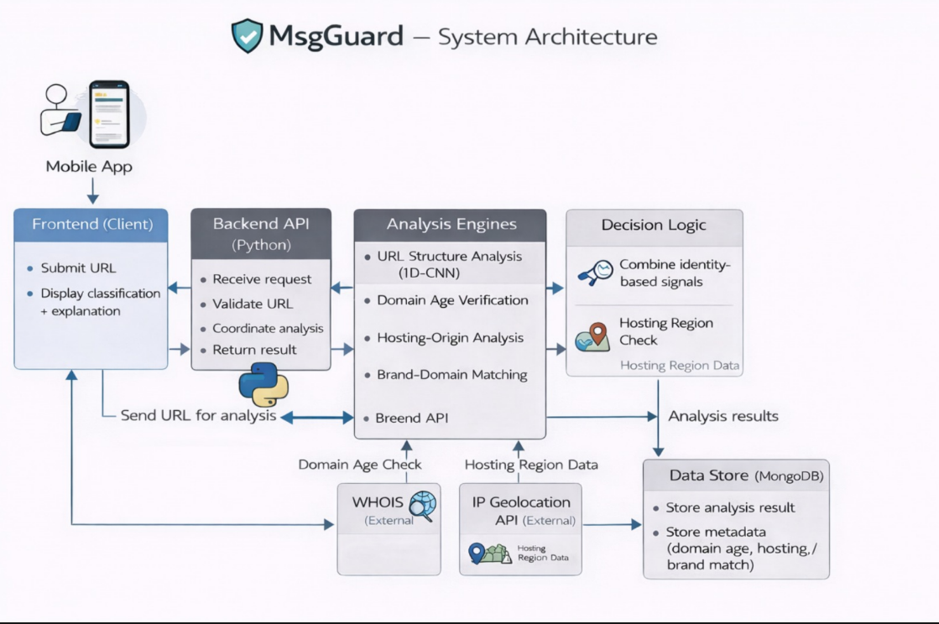
Figure 1: MsgGuard System Architecture
The system architecture of MsgGuard follows a modular client–server design that separates user interaction, request coordination, analysis processing, decision logic, and data storage into distinct components. This structure improves maintainability, scalability, and clarity of responsibility.
The process begins at the mobile application, which serves as the frontend client. The frontend allows the user to submit a suspicious URL or message and is responsible only for collecting input and displaying the final classification and explanation. No detection logic is executed on the client side.
The submitted data is sent to the backend API, implemented in Python, which acts as the central coordination layer of the system. The backend receives requests from the frontend, validates the input format, and manages communication with the analysis engines. It does not perform detection itself, but orchestrates the execution of multiple analysis modules.
The analysis engines perform both machine-learning-based and identity-based evaluations. URL structure analysis is conducted using a deep-learning model (1D-CNN) that evaluates lexical and structural patterns in URLs. In parallel, identity-based verification modules assess domain age using external WHOIS services, analyze hosting origin using IP geolocation APIs, and perform brand–domain matching to detect impersonation attempts. These external services provide supplementary identity signals that are not available from the URL alone.
The outputs of the analysis engines are forwarded to the decision logic component, which aggregates the different indicators and computes a final risk score and phishing classification. This component also determines the dominant factors contributing to the decision, which are later used to generate human-readable explanations.
All analysis results and metadata, including domain age, hosting region, and brand similarity indicators, are stored in the MongoDB data store. This enables future performance evaluation, logging, and system improvement based on historical detection patterns.
Finally, the backend constructs a response containing the classification result, risk score, and explanation and returns it to the frontend, where it is presented to the user in an understandable format.
This modular architecture enables flexible extension of detection methods, supports integration of additional identity verification services, and ensures clear separation between user interface, control logic, detection processing, and data persistence.

4.2.2 Use Case Diagram

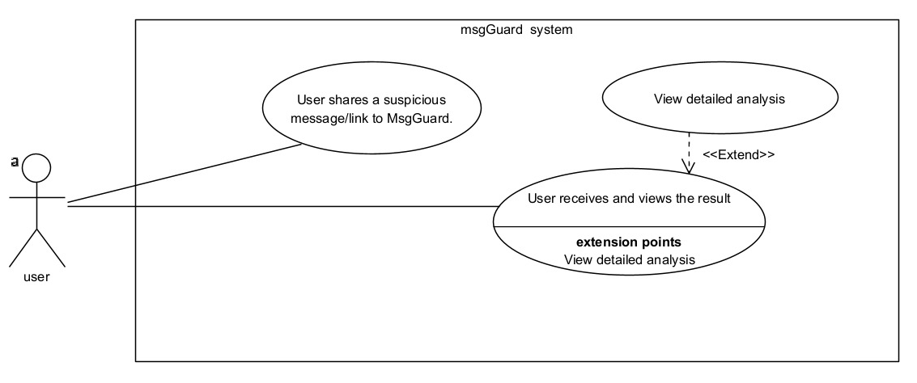
Figure 2: MsgGuard Use Case Diagram

This use case diagram illustrates the primary interactions between the user and the MsgGuard system. It focuses on the external behavior of the system as experienced by the user, without exposing internal processing or system components.
The first use case represents the action of sharing a suspicious message or link with the MsgGuard application. Using the mobile operating system’s sharing functionality, the user forwards content from messaging or email applications directly to MsgGuard, initiating the phishing analysis process.
The second use case represents the user receiving and viewing the analysis result after the system completes processing. The result includes the phishing classification, risk level, and explanatory information that supports informed decision-making by the user.

4.2.3 Activity Diagram
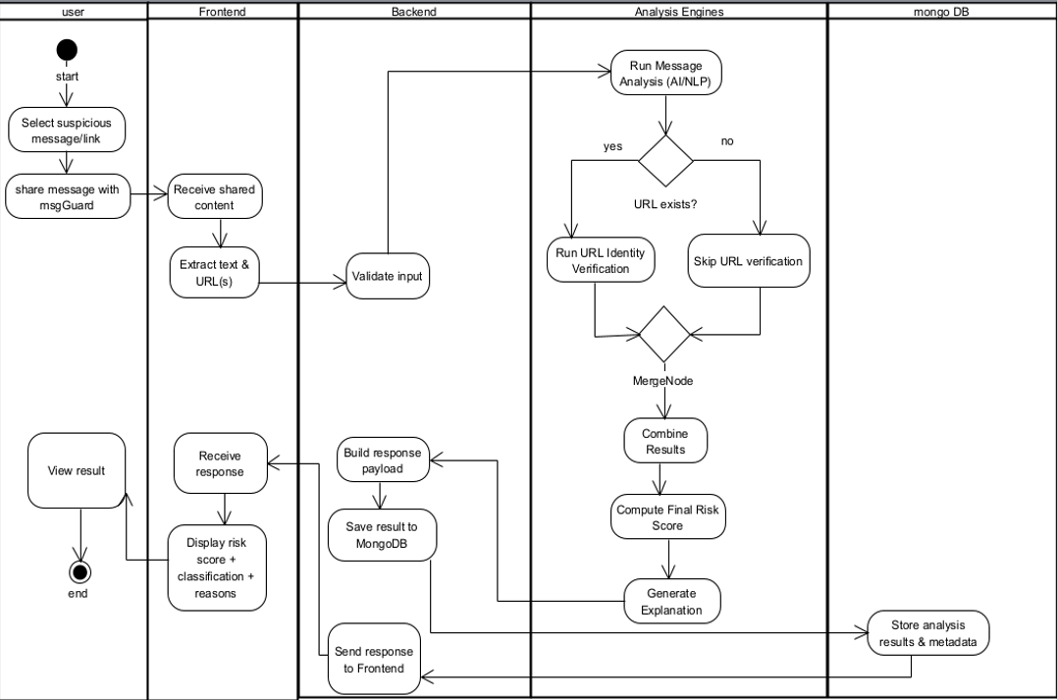
Figure 3: MsgGuard Activity Diagram.
The process begins when the user selects a suspicious message or link and shares it with the system. The frontend receives the shared content and extracts relevant elements, including textual content and embedded URLs. The extracted input is then sent to the backend, where initial validation is performed to ensure that the data format is suitable for further analysis.
Once the input is validated, the backend forwards the data to the analysis engines. First, message-level analysis is executed using AI and natural language processing techniques to evaluate suspicious language patterns and contextual signals. The system then checks whether a valid URL is present in the content. If a URL exists, the system performs identity-based URL verification, which includes checks such as domain characteristics and brand–domain consistency. If no URL is detected, the system skips URL verification and continues with message-based analysis only.
After completing the relevant analyses, the system merges the results from the different detection modules and combines all signals into a unified evaluation stage. A final phishing risk score is computed based on the aggregated indicators, and an explanation is generated to describe the main reasons contributing to the decision.
The analysis results and associated metadata are then stored in the database for future reference, monitoring, or offline evaluation. In parallel, the backend builds a response payload containing the classification result, risk score, and explanation, and sends it to the frontend.
Finally, the frontend receives the response and displays the phishing classification, risk level, and explanation to the user. The user reviews the result, completing the interaction workflow.
This activity flow demonstrates how message analysis, URL identity verification, and result explanation are integrated into a single automated pipeline while maintaining modular processing and clear responsibility separation across system components.

4.2.4 User Interface (UI)

Page 1 – Message Sharing and Input
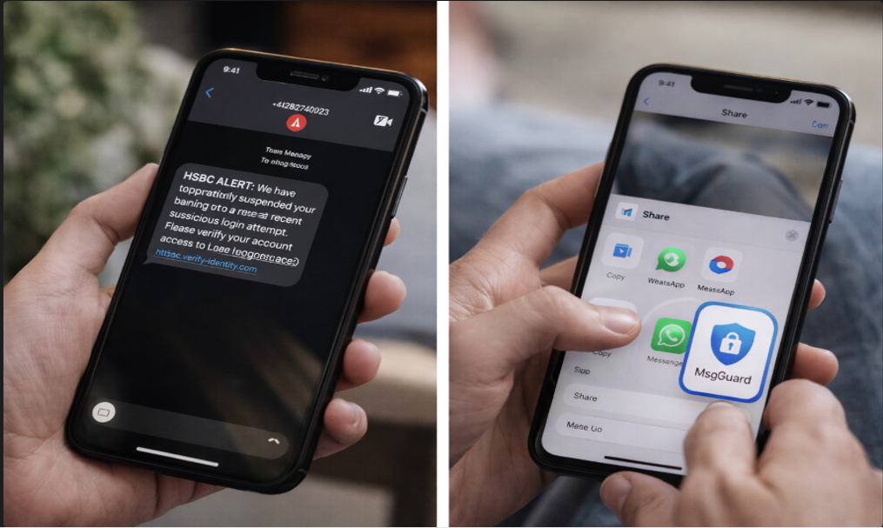
Figure 4(a): MsgGuard User Interface – Message Sharing and Input.

This interface represents the first interaction stage between the user and the MsgGuard phishing detection system. The user receives a suspicious message or link in an external messaging or SMS application and initiates the analysis by selecting the system’s share option.
Using the mobile operating system’s built-in sharing functionality, the user forwards the suspicious content directly to the MsgGuard application. This design eliminates the need for manual copying or pasting of URLs and allows seamless integration with existing messaging platforms such as SMS, WhatsApp, or email clients.
Once the content is shared, MsgGuard automatically receives the message and extracts the relevant information, including the full text and any embedded URLs. No results are displayed at this stage, as the system immediately begins background analysis of the submitted content. The user is therefore not required to perform any additional actions beyond sharing the message.
This interface design reduces user effort, encourages rapid reporting of suspicious content, and supports real-time phishing detection in natural user workflows, making the system practical for everyday use.

Page 2 – Analysis and Results Display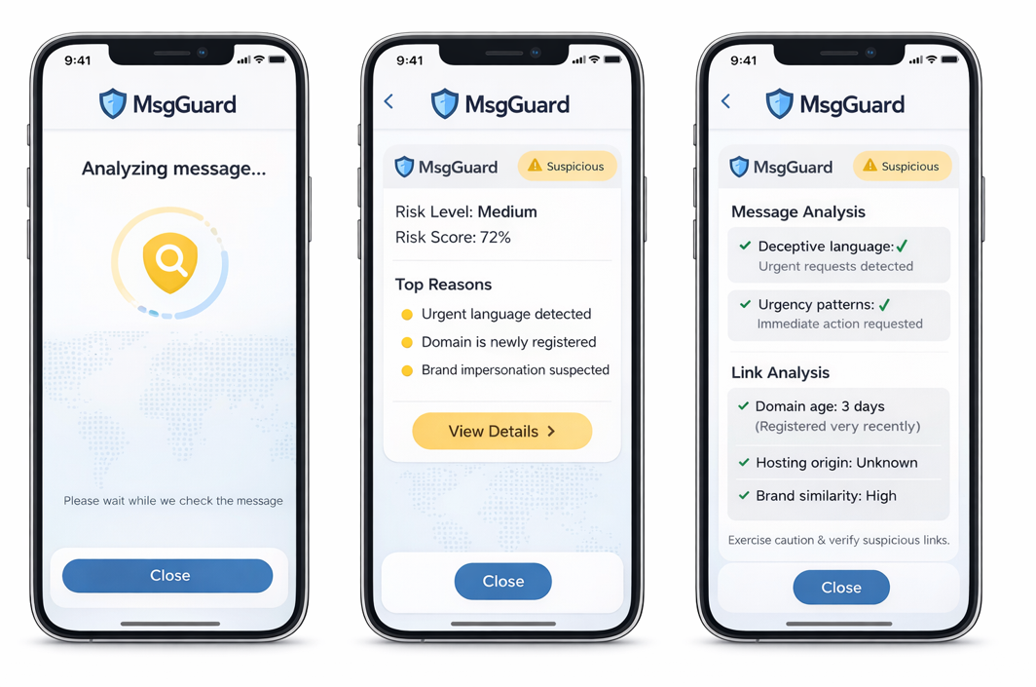
Figure 4(b): MsgGuard User Interface – Analysis and Results Display.

This interface represents the analysis and feedback stage of the MsgGuard application. After the user shares a suspicious message, the system displays an intermediate analysis screen indicating that the message is currently being processed. A visual progress indicator and status message inform the user that detection is actively running, reducing uncertainty and improving user trust in the system’s operation.
Once the analysis is completed, the system presents a summarized risk assessment that includes a qualitative risk label (e.g., Suspicious), a numerical risk score, and an overall risk level. This high-level summary allows users to quickly understand whether the message is potentially dangerous without requiring technical knowledge.
The interface also displays the top contributing reasons for the classification, such as urgent language usage, recently registered domains, or suspected brand impersonation. These reasons provide immediate interpretability and help users understand why the system reached its conclusion.
Users can optionally view detailed analysis results by selecting the “View Details” option. The detailed view separates message-based indicators (e.g., deceptive wording or urgency patterns) from link-based indicators (e.g., domain age, hosting origin, brand similarity), allowing users to clearly see how different evidence sources contributed to the final decision.
Finally, the interface provides guidance encouraging caution when interacting with suspicious links, while allowing the user to close the analysis screen and return to the original application. This design supports informed decision-making while maintaining a simple and user-friendly workflow.

5. Verification And Evaluation

5.1 Verification
The following representative test scenarios are defined to verify the correct behavior of the phishing detection system and its main identity-based components.
Test Case 1 – Legitimate URL
A known official brand URL is submitted to the system. The system is expected to recognize the correct domain, report a normal domain age, and produce a Legitimate classification with a clear explanation.
Test Case 2 – Newly registered phishing domain
A URL associated with a recently registered domain is analyzed. The system is expected to flag the low domain age as suspicious and classify the URL as Suspicious or Phishing, with domain age mentioned in the explanation.
Test Case 3 – Brand impersonation via domain structure
A URL that imitates a known brand using a misleading domain or subdomain is submitted. The system is expected to detect the mismatch between the suspicious domain and the official brand domain and classify the URL as Phishing.
Test Case 4 – Hosting-origin inconsistency
A URL claiming to represent a well-known brand is hosted in an unexpected region or infrastructure. The system is expected to identify the hosting-origin inconsistency and reflect this risk in the final classification and explanation.
Test Case 5 – Invalid or malformed URL
An incorrectly formatted URL is provided as input. The system is expected to reject the input and return an appropriate error message without performing further analysis.
Test Case 6 – Misleading subdomain usage
A URL places the brand name in a subdomain while the actual registered domain is unrelated. The system is expected to correctly extract the true domain, detect the misleading subdomain structure, and classify the URL as Phishing or Suspicious, with this reason included in the explanation.
Test Case 7 – Unusual or deceptive top-level domain (TLD)
A URL uses an uncommon or suspicious top-level domain for a known brand. The system is expected to identify the mismatch between the official brand domain and the used TLD and classify the URL as Suspicious or Phishing, mentioning the TLD inconsistency in the explanation.
Test Case 8 – Long-established domain with suspicious structure
A URL has an old domain registration age but uses a domain structure that imitates a known brand. The system is expected to treat the domain age as low risk but still flag the brand–domain mismatch and classify the URL as Suspicious or Phishing.
Test Case 9 – Multiple phishing indicators combined
A URL exhibits several risk signals simultaneously, such as recent domain registration, brand–domain mismatch, and hosting-origin inconsistency. The system is expected to classify the URL as Phishing and include all contributing risk factors in the explanation.
Test Case 10 – Known legitimate brand with multiple hosting locations
A known official brand URL is hosted in a region that differs from its typical hosting location. The system is expected to apply flexible hosting-origin rules, avoid false positives, and classify the URL as Legitimate if no other risk indicators are present.

5.2 Evaluation
The system is verified through end-to-end testing, in which each submitted URL is processed by the complete analysis pipeline, including machine-learning classification and identity-based verification components. Evaluation is conducted using a set of predefined verification test cases that represent legitimate websites, phishing attempts, and zero-day or unfamiliar domains. The test set includes URLs collected from public datasets as well as manually constructed examples that simulate common attack patterns such as brand impersonation, misleading subdomains, and uncommon top-level domains.
For each test case, the system produces a final classification (legitimate or phishing), a risk score, and a list of contributing indicators, such as domain age, brand–domain mismatch, hosting origin, and URL structure. These outputs are compared with the expected behavior defined for each scenario. A test case is considered successful when the classification label is correct and when the explanation reflects the dominant risk indicators relevant to that case.
Evaluation is performed across multiple categories of scenarios, including legitimate brand URLs, newly registered domains, brand-imitation domains, unusual TLD usage, and cases with conflicting signals. Robustness is additionally tested using malformed or invalid URLs to verify that the system handles errors safely and reports failures clearly without unnecessary processing.
In addition to qualitative verification, quantitative performance is measured using metrics such as detection rate, false positive rate, and overall accuracy by comparing system predictions to ground-truth labels. Particular attention is given to borderline cases in which identity-based features are expected to influence or strengthen the final decision beyond the baseline machine-learning model. This evaluation approach verifies both reliable phishing detection and transparent, explainable system behavior across diverse scenarios.

6. References
[1] Nguyet Q., Ali S., Ondryj K. Deep Learning for Phishing Detection: Taxonomy, Current Challenges, and Future Directions. IEEE Access, 2022.
https://doi.org/10.1109/ACCESS.2022.3151903

[2] Maruf A., Khin L., Alamgir H. Intelligent phishing detection scheme using deep learning algorithms. Journal of Enterprise Information Management, 2020.
https://www.emerald.com/jeim/article/36/3/747/203279/Intelligent-phishing-detection-scheme-using-deep Emerald
[3] Samer Atawneh, Hamzah Aljehani. Phishing Email Detection Model Using Deep Learning. Electronics, 12(20), 4261, 2023.
https://www.mdpi.com/2079-9292/12/20/4261
[4] Cagatay Catal, Görkem Gül, Bider T. Applications of Deep Learning for Phishing Detection: a Systematic Literature Review. Knowledge and Information Systems, 2022.
https://pmc.ncbi.nlm.nih.gov/articles/PMC9125357/
[5] Sultan Asiri, Yang Xiao, Saleh Alzahrani, Tieshan Li. PhishingRTDS: A Real-time Detection System for Phishing Attacks Using a Deep Learning Model. Computers & Security, 2024.
https://www.sciencedirect.com/science/article/abs/pii/S0167404824001445 ScienceDirect
[6] Bryan Lim, Roman Huerta, Alejandro Sotelo, Anthonie Quintela, Priyanka Kumar. EXPLICATE: Enhancing Phishing Detection through Explainable AI and LLM-Powered Interpretability. arXiv, 2025.
https://arxiv.org/abs/2503.20796 arXiv
[7] Saba Aslam, Hafsa Aslam, Arslan Manzoor, Chen Hui, Abdur Rasool. AntiPhishStack: LSTM-based Stacked Generalization Model for Optimized Phishing URL Detection. arXiv, 2024.
https://arxiv.org/abs/2401.08947 arXiv
[8] Qazi Haq, Iftikhar A. Detecting Phishing URLs Based on a Deep Learning Approach. Applied Sciences, 2024.
https://www.mdpi.com/2076-3417/14/22/10086 MDPI
[9] Anish Rawla, Preeti (et al.). Detection of Phishing Attacks in PhiUSIIL Dataset Using Deep Learning. Procedia Computer Science, 2025.
https://www.sciencedirect.com/science/article/pii/S1877050925011007 ScienceDirect
[10] Dinnillah A.H., Widiarto M., Wijaya A. Robust Phishing Detection Using Random Forest with Isolation Forest Based Outlier Filtering. IJACI, 2025.) https://journal.cendekiajournal.com/ijaci/article/view/16

